SAFCA CONTRACTING POLICY

PURPOSE

To provide policy guidelines for the development, awarding and administration of Sacramento Area Flood Control Agency (SAFCA or Agency)) contracts.

BACKGROUND

Section 19(c) of the Joint Exercise of Powers Agreement (JEPA) states that the Executive Director shall have the power, “To authorize expenditures within the designations of the approved Budget”. Additionally the JEPA provides SAFCA with the power “[T]o make and enter contracts necessary to the full exercise of its powers”” (Section 7.(d)) and “[T]”o contract for the services of engineers, attorneys, planners, financial consultants, …” (Section 7.(e)).

Through various actions by the SAFCA Board of Directors (Board), the Executive Director and designated staff have been given delegated authority for contracting within designated limits for various contract transaction types.

This Policy and procedure establishes the baseline activities for the performance of contracting for goods, services, and construction activities including those delegated and code required parameters.

CONTRACT TYPES

Commodities & Equipment: Contracts for the purchase of supplies, materials and equipment. Equipment is a capital asset with an aggregate cost in excess of $5,000 having a useful life expectancy of five (5) years or more.

Services: Provision of technical services to agency for property, equipment or general operational activities.

Professional Services/Consultant: Provide professional or expert advice in relation to capital projects, technical analysis, intergovernmental relations, legal services and financial services.

Public Works: For the performance of capital projects or repair of existing facilities.

Real Property: Real property acquisitions, conveyances, license agreements and utility relocation agreements.

Inter-Agency Agreements: Include and are not limited to Cost Sharing Agreements, Cooperative Agreements and Service Agreements.

CONTRACTING AUTHORITIES

Authority for the execution of agreements is provided to SAFCA through California Government code related to local government and Joint Powers Authorities. The SAFCA Act (Water Resources Code Chapter 130) and the JEPA provides broad authority for the Agency’s Executive Director to authorize expenditures within the designations and limitations of the approved budget. The Board of Directors has limited some of these authorities through subsequent resolutions since the Agency was formed. In addition, SAFCA must also conform with California Codes and regulations pertaining to the purchasing and contracting of goods and services. The following section provides the source of contracting authorities for each of the previously identified contract types.

Commodities & Equipment

Authority for the purchase of supplies, materials and equipment is provided through the Interagency Agreement with Sacramento County. Through the agreement SAFCA utilizes the County purchasing policy as a guideline for procurement of goods and services as described in the County purchasing policies. Purchases of Commodities and Equipment are authorized by the SAFCA Board of Directors with the adoption of the annual budget or through individual Board action.

Services

Provision of technical services to the Agency for property, equipment or general operational activities is performed through either the Interagency Agreements, Professional Services Agreements or through Public Works contracting as described in the Summary Table of Public Works Contracting and Authority on page 3.

Professional Services/Consultant

Provision of Professional Services of Consultant Services includes but is not limited to expert advice in relation to capital project engineering, technical analysis, intergovernmental relations, legal services and financial services. The SAFCA Board has provided delegated authorities for the Executive Director or his designee to enter into Professional Service Agreements. In accordance with Board Resolution No. 2012-144, the Executive Director is authorized to enter into contracts up to $100,000. Such Contracts shall be reported to the Board of Directors on a Quarterly basis.

Public Works

Contracting for Public Works is authorized through the Public Contract Code and related sections under the California Uniform Public Construction Cost Accounting Act (CUPCCAA). CUPCCAA allows for public project work in the amount of $60,000 or less to be performed by the public agency’s force account, by negotiated contract, or by purchase order. Public projects in the amount of $200,000 or less can use the informal bidding procedures set forth in the Act. Public projects at a cost of more than $200,000 shall use formal bidding procedures to let the contract pursuant to Public Contract Code (PCC) Section 22032(c).

SAFCA utilizes the formal public works bidding procedures applicable to Sacramento County (PCC section 20210 et seq.) pursuant to JEPA Section 7.(p).

The Executive Director, or his designee, will determine the applicable contracting method to be used that meets the Public Works appropriate contracting authorities and needs of the agency.

The contracting limits by type and contracting authority are shown in the following Summary Table of Public Works Contracting and Authority.

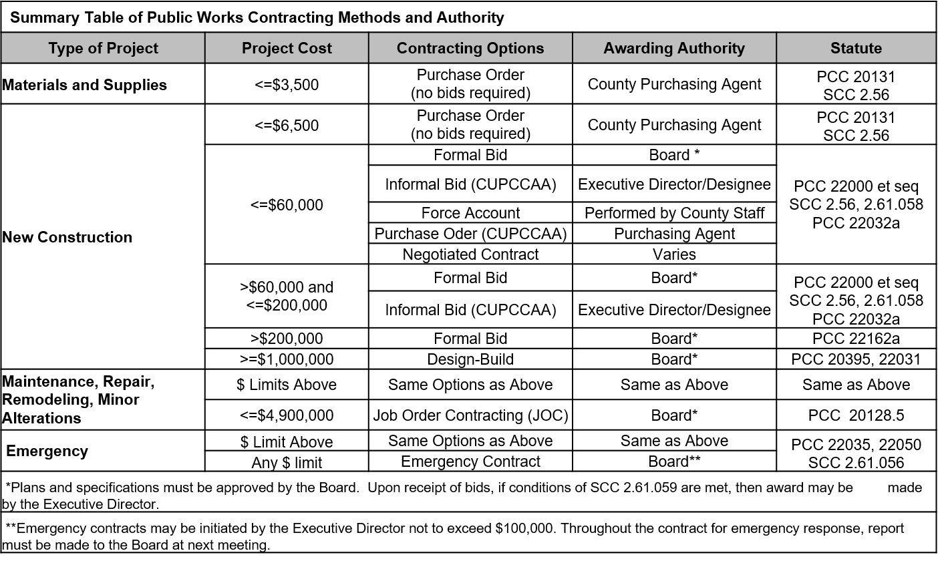

In addition to the authorities provided through the Public Contract Code, the SAFCA Board has delegated to the Executive Director and his designee various specific authorities related to Public Works contracts. The following public works actions have been delegated.

CONSTRUCTION CONTRACT CHANGE ORDERS

- Change orders shall not exceed five thousand dollars ($5,000) for construction contracts with original contract amounts that do not exceed fifty thousand dollars ($50,000); provided the sum of all such change orders issued by the Executive Director shall not exceed $25,000;

- Change orders shall not exceed ten percent of the original contract amount for construction contracts with original contract amounts between $50,001 and $250,000; provided the sum of all such change orders issued by the Executive Director shall not exceed $50,000;

- Change orders shall not exceed twenty-five thousand dollars ($25,000), plus five percent of the amount of the original contract cost in excess of two hundred fifty thousand dollars ($250,000). In no event shall any such change or alteration exceed two hundred ten thousand dollars ($210,000); and provided the sum of all such change orders issued by the Executive Director shall not exceed ten percent (10%) of the original contract amount;

- If the Executive Director issues one or more change orders to increase the contract amount pursuant to the authorities listed in sections (a), (b) or (c) above, and the Board of Directors subsequently ratifies the change order(s) or alteration(s) previously issued by the Executive Director, the Executive Director’s authority to issue additional change orders as specified in Sections (a), (b) and (c) above is reset. The new “original contract amount” shall then be the total of the original contract amount plus all previously issued change orders or alterations; and

- For contracts in any amount, the Executive Director shall have the authority to issue change orders or alterations that decrease or do not change the contract amount.

SAFCA staff will provide the Board with written quarterly reports of all construction contracts that are awarded and construction contract change orders that are approved pursuant to this delegated authority.

EMERGENCY CONTRACTS

In the case of an emergency, a public agency, pursuant to a four-fifths vote of its governing body, may repair or replace a public facility, take any directly related and immediate action required by that emergency, and procure the necessary equipment, services, and supplies for those purposes, without giving notice for bids to let contracts. PCC Section 22050.

Sometimes it is necessary for SAFCA to respond to an emergency situation prior to being able to present a contract for emergency services to the Board for approval. Board Resolution No. 97-014 gives the Executive Director’s signature authority to execute contracts for emergency services. The Executive Director's signature authority for emergency services is limited to a maximum of $100,000 per contract. When an emergency contract is executed, the Executive Director will report to the Board at the next scheduled meeting that an emergency services contract was issued, the situation under which it was issued, the expected duration of the emergency situation and the source of funding for the contract.

UTILITY RELOCATION AGREEMENTS

In accordance with Resolution No.01-055, the Executive Director is authorized to execute agreements up to $50,000 for utility companies to relocate their respective facilities as a result of SAFCA projects.

MAINTENANCE ACTIVITIES

In accordance with Resolution No. 01-055, the Executive Director is authorized to execute agreements up to $50,000 for maintenance of SAFCA properties. Furthermore, SAFCA has elected to participate in the California Uniform Public Construction Cost Accounting Act (CUPCCAA). The act provides authority for the performance of maintenance activities up to $60,000 under through purchase order and up to $200,000 through informal bidding.

CONSTRUCTION CLOSEOUT AUTHORITIES

In accordance with Resolution No, 2015-111, the Executive Director is authorized to accept constructions contracts as complete and to approve final quantities and a final contract amount when the final contract amount does not exceed $200,000.

REAL PROPERTY

Real property transactions relate to the performance of obligations for the delivery of flood risk reduction efforts, the provision of space for SAFCA operations, and various other support functions. Authority for the execution of Real Property agreements resides with the SAFCA Board of Directors unless explicitly delegated. Delegated authorities for real property acquisitions, conveyances, license agreements and utility relocation agreements are provided through several Board resolutions.

- In accordance with the delegated authorities provided by Resolution No. 2015-110, the Executive Director is authorized to execute real property transactions on behalf of SAFCA where just compensation does not exceed $500,000. The Executive Director shall report to the Board on a quarterly basis all acquisition documents executed pursuant to this authority.

- In accordance with the delegated authorities provided by Resolution No. 2014-013, the Executive Director is authorized to take the following actions:

  - Grant or otherwise convey an easement, license, or permit for use of any real property of the Agency to the State, or to any county, city, district, or public agency or corporation, or to any public utility corporation in the manner and upon the terms and conditions as the Executive Director determines or prescribes, upon a finding by the Executive Director that the conveyance is in the public interest and that the interest in land conveyed will not substantially conflict or interfere with the use of the property by the Agency.

  - Where the Board has authorized the Executive Director to execute funding agreements with the State or other public agencies and those agreements provide for SAFCA to acquire real property interests and to subsequently convey, to the funding partner or other entity, all or portions of the real property interests so acquired, the Executive Director is hereby authorized to comply with the terms of such agreements.

  - Where the processing of a Board approved eminent domain action has taken an existing easement and the Stipulation for Judgment, Judgment in Condemnation, or Final Order of Condemnation provides that the Agency with provide a replacement easement, the Executive Director is hereby authorized to comply with the terms of such court documents.

  - Notwithstanding any other provision of law, and in compliance with Government Code Section 25026.6, the Executive Director is hereby authorized to lease any real property of the Agency to the State, or to any county, city, district, or public agency or corporation, or to a public utility corporation, or to a member of the public in the manner and upon the terms and conditions as the Executive Director determines or prescribes, upon a finding by the Executive Director that the lease of the property is in the public interest and that the lease of the land will not substantially conflict or interfere with the use of the property by the Agency.

- In accordance with the delegated authorities provided by Resolution No. 2009-128, the Executive Director is authorized to take the following actions:

  - The Executive Director is authorized to commence the appraisal process, including authorizing a right-of-way consultant to send out notices of the agency's decision to appraise.

  - The Executive Director is authorized to review and approve appraisals.

  - The Executive Director is authorized to establish the amount of just compensation for the real property to be acquired by SAFCA and the amount required for the relocation of displaced persons, and approve the appropriation of funds therefore.

  - The Executive Director is authorized to approve the written offers of just compensation to acquire real property based on approved appraisal values as required by Government Code § 7267.2.

  - The Executive Director is authorized to approve requests for appraisal revisions and administrative settlements up to ten percent (10%) over the appraised value to a maximum amount of $500,000. In such an event, the Executive Director must make a written report, after the fact, to the Board of Directors of the appraisal revisions and/or administrative settlements.

  - The Executive Director is authorized to accept deeds and easement documents on behalf of the Board, conveying real property to SAFCA for recording in accordance with Government Code § 27281.

  - The Executive Director is authorized to direct Agency Counsel to initiate legal action to obtain access to property where: (a) such access is necessary in order for SAFCA to obtain the data to support applications for or compliance with regulatory permits necessary to construct the Agency's projects or such access is necessary in order to obtain the data required to prepare the design of the Agency's projects, or both; and (b) the property owner has refused or failed to grant the required permission to SAFCA after having been requested to do so in writing, provided such actions are reported to the Board of Directors in writing prior to initiation of legal action.

  - The Executive Director is authorized to take such further actions as may be reasonably necessary from time to time, to carry out the objectives and purposes set forth by this Resolution, which may include executing rights of entry for construction, engineering, and environmental surveys, and filing of petitions for access with the Courts.

- In accordance with the delegated authorities provided by Resolution No. 94-029, the Executive Director is authorized to take the following actions:

  - The Executive Director is authorized to execute license agreements with Union Pacific Railroad for temporary and permanent encroachments into Union Pacific rights-of-way.

  - The Executive Director is authorized to reimburse Union Pacific Railroad for expenses incurred in providing services to SAFCA associated with encroachments, up to a limit of $100,000 for each agreement.

INTER-AGENCY AGREEMENTS

Inter-Agency Agreements relate to the efforts required to deliver flood risk reduction efforts and for the maintaining of flood related improvements. In some instances, it is necessary for SAFCA to enter into cost sharing agreements for the performance of technical, regulatory and professional services. Delegated authorities for Inter-Agency cost sharing agreements have been provided by the SAFCA Board.

- In accordance with the delegated authorities provided by Resolution No. 2014-012, the Executive Director is authorized to execute cost sharing agreements with other public agencies. SAFCA payments under these such agreements shall not exceed $100,000. The execution of agreements under this authority shall be reported to the Board on a quarterly basis.

CONTRACTING PROCEDURES GENERAL POLICIES

- In accordance with the authorities provided through the SAFCA Act and delegated to the Executive Director, SAFCA contracts must be reviewed and approved for legal sufficiency by Agency Counsel. Final approval for contracts will be by the Board of Directors or Executive Director, based on the contract type and relative authority to execute the agreement.

- All contracts must have an identified appropriation in the budget adopted by the SAFCA Board each fiscal year or shall receive Board Authorization for appropriations through a separate Board action.

- The contract term shall be appropriate for the services provided, including long term program technical services associated with modeling, engineering and mitigation support services.

- Development and renewal of contracts shall be done in sufficient time to fully execute the new contract before the current contract expires.

- No work shall commence prior to the execution of the contract.

VENDOR SELECTION

Commodities & Equipment

Contracts for the purchase of supplies, materials and equipment will be procured under the Interagency Agreement with Sacramento County and in accordance with the Sacramento County Purchasing policies and procedures. Sacramento County Purchasing Services provides procurement services for SAFCA in accordance with their County policies and procedures and as modified by SAFCA specific contracting authorities.

Services

Provision of technical services to the Agency for property, equipment or general operational activities is performed through various contracts in accordance to relative codes and regulations. SAFCA generally contracts for services through interagency agreements. In addition, SAFCA issues requests for proposals (RFP), requests for qualifications (RFQ), and invitations for bid (IFB) for services on an as needed basis.

Professional Services/Consultant

Selection of firms and/or individuals for the provision of Professional Services is based on professional qualifications and demonstrated competence necessary for the satisfactory performance of the services required. A variety of methods can be used for the selection of Professional Services providers. Qualifications based selections typically include the issuance of a request for qualifications (RFQ). Statements of Qualifications are reviewed and ranked based on the evaluation criteria stated in the RFQ. Based on the Agency’s needs, SAFCA may seek both broad–based and category specific services, and may select multiple service providers per solicitation. Sole source contracts are justified in some situations where specialized knowledge, skills or abilities are required. Justification for sole source contracts are reviewed by Agency Counsel and Deputy Executive Director and placed in the contract file.

Public Works

Vendor sections for public works projects is performed in accordance with the applicable statutes, regulations and policies described above in Contracting Authorities.

